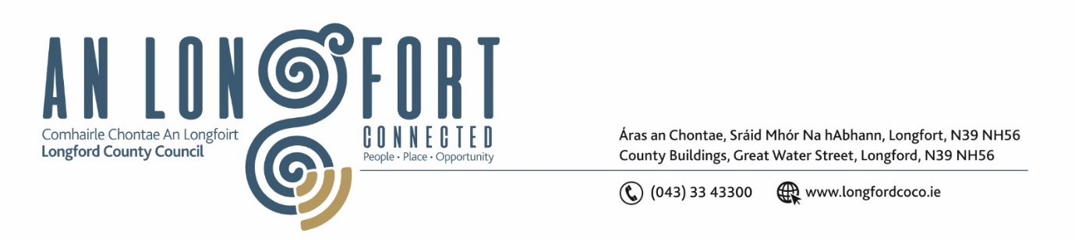

**LONGFORD MUNICIPAL DISTRICT**

***Please note meeting will be held in the Council Chamber, Aras an Chontae and via Microsoft Teams***

**15 March 2023.**

**To: Each Member of Longford Municipal District.**

**Dear Member,**

You are requested to attend the Meeting of Longford Municipal District to be held in **the Council Chamber, Aras an Chontae** and **via Microsoft Teams** on **Wednesday 22 March 2023 at 3.30pm** to transact business, as set out on the agenda hereunder.

**Yours sincerely**,

_______________

**Claire McNabola**

**Meetings Administrator**

**AGENDA**

Prayer before meeting.

Presentation from Healthy Age Friendly Homes Local Coordinator.

**1.** Confirmation of Minutes:

1. Longford Municipal District Meeting held on Wednesday 22 February 2023 – enclosed.
2. Longford Municipal District Committee Meeting held on Wednesday 22 February 2023 – enclosed.

**2.** Matters arising from Minutes.

**3.** Declaration of Interest by Members.

**4.** Management Report – enclosed.

**5.** Consideration of Draft Bye Laws (Roads)

**6.** Nominations of Elected members for the Creative Ireland Culture Team 2023-2027

**7.** Funding for Festivals Update – funding applied for event for Africa Day on behalf of Longford African Network

**8.** Naming of Carriglass Roundabout

**9.** Consideration of Schedule of Longford Municipal District Works – enclosed

**10.** **Notices of Motions, submitted by Councillors, as listed hereunder –**

**Councillor Gerry Warnock**

I’m calling on Longford Municipal District to place Dog Poop Bins at either end of the Longford Canal Walkway.

**Councillor Uruemu Adejinmi**

1. I call on Longford County Council to make it safer for pedestrians accessing Market Square from New Street by implementing a signalised pedestrian crossing at the junction of New Street.
2. I call on Longford County Council to contact the Five Star Pizza business owner and the Landlord to relocate the bins left permanently on the public access area of Garvey's Yard. The location of the bins results in rubbish left scattered around them making the area unsightly and a health and safety risk, causing great distress to residents and people accessing the Annaly carpark via Garvey’s Yard.